**CSE3011 NETWORK PROGRAMMING**

**LAB EXPERIMENT 11**

NAME – B PRATYUSH

REGISTRATION NUMBER – 19BCN7114

FACULTY – PROF. MUNEESWARI

**Experiment Description: Reading and writing from HTTP Server**

**Reading from Server**

**HttpServer.java**

**package** Lab11;

**import** java.net.*;

**import** java.io.*;

**public** **class** HttpServer{

**public** **static** **void** main (String[] args) {

**for** (**int** i = 0; i < args.length; i++)

{

**try**

{

URL u = **new** URL(args[i]);

HttpURLConnection uc = (HttpURLConnection) u.openConnection( );

**int** code = uc.getResponseCode( );

String response = uc.getResponseMessage( );

System.***out***.println("HTTP/1.x " + code + " " + response);

**for** (**int** j = 1; ; j++)

{

String header = uc.getHeaderField(j);

String key = uc.getHeaderFieldKey(j);

**if** (header == **null** || key == **null**)

{

**break**;

}

System.***out***.println(uc.getHeaderFieldKey(j) + ": " + header);

}

InputStream in = **new** BufferedInputStream(uc.getInputStream( ));

Reader r = **new** InputStreamReader(in);

**int** c;

**while** ((c = r.read( )) != -1)

{

System.***out***.print((**char**) c);

}

System.***out***.println();

}

**catch** (MalformedURLException ex)

{

System.***err***.println(args[0] + " is not a parseable URL");

}

**catch** (IOException ex)

{

System.***err***.println(ex);

}

}

}

}

**Output**

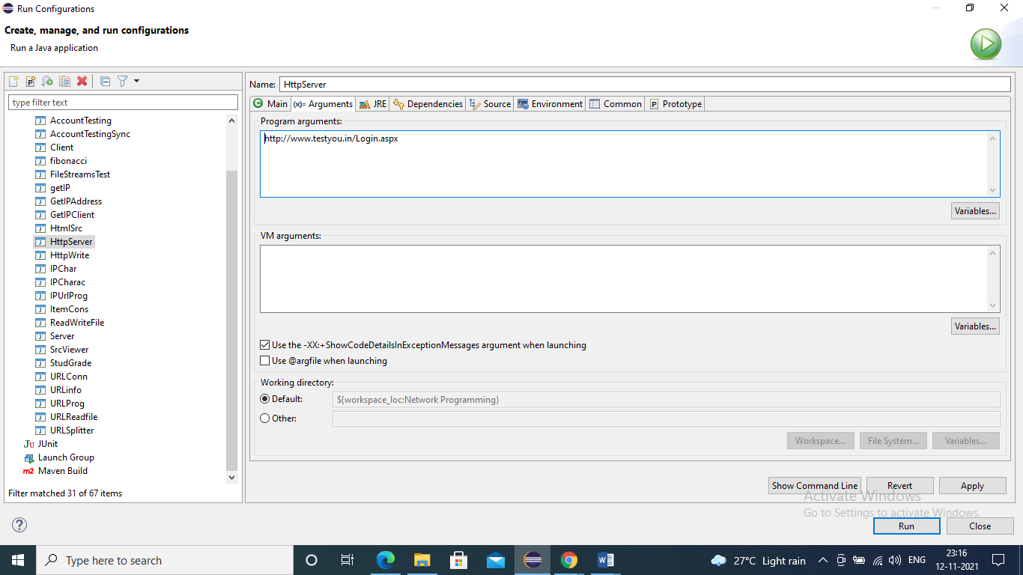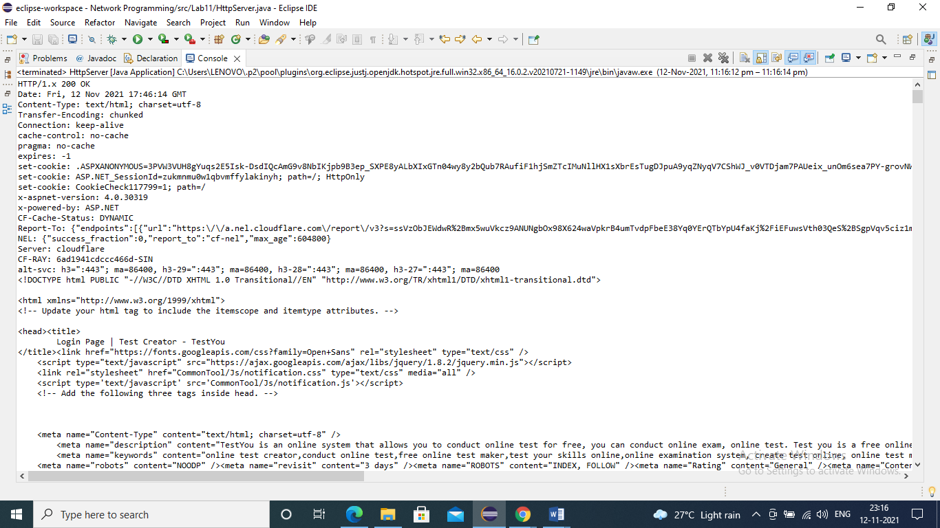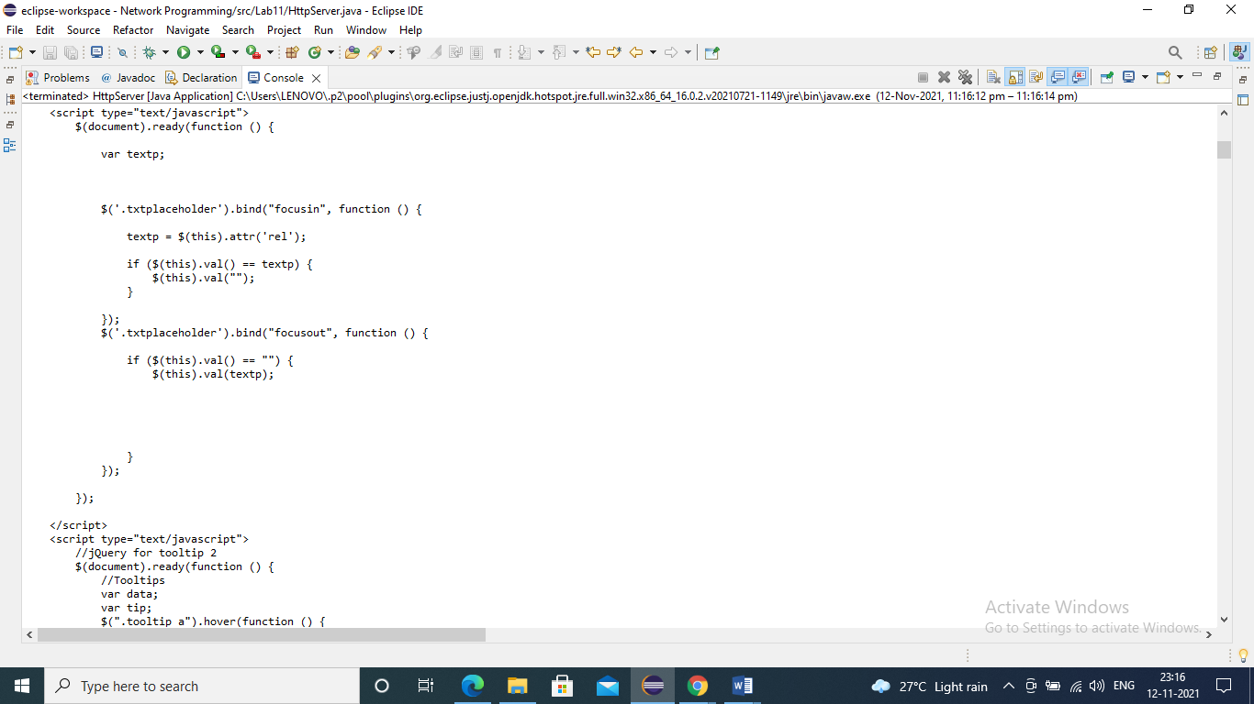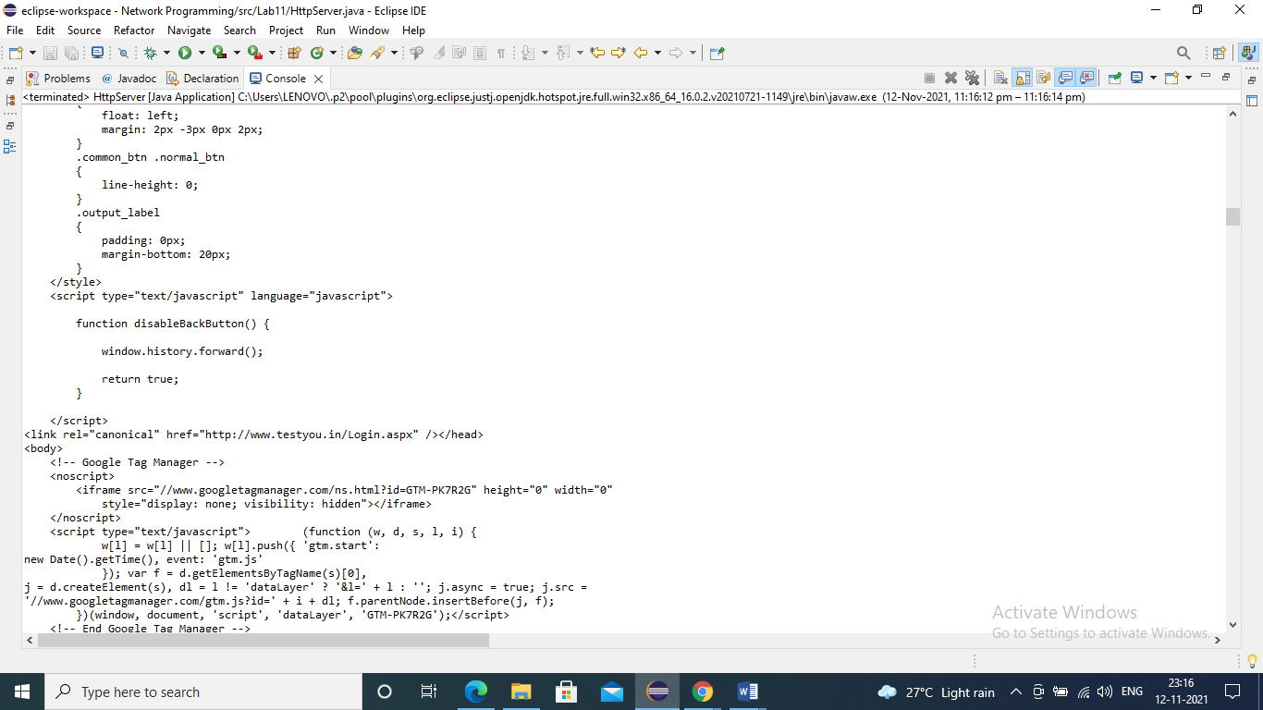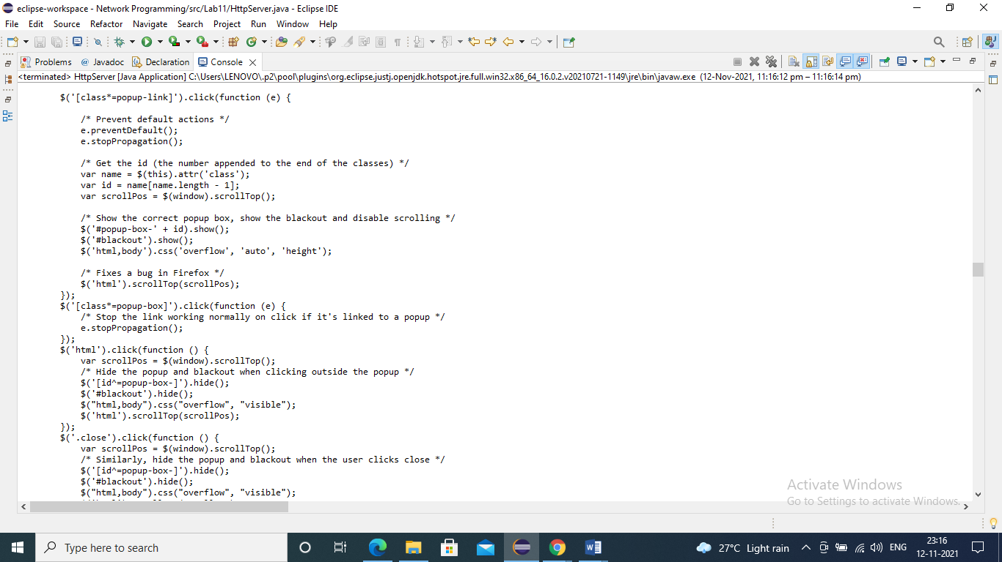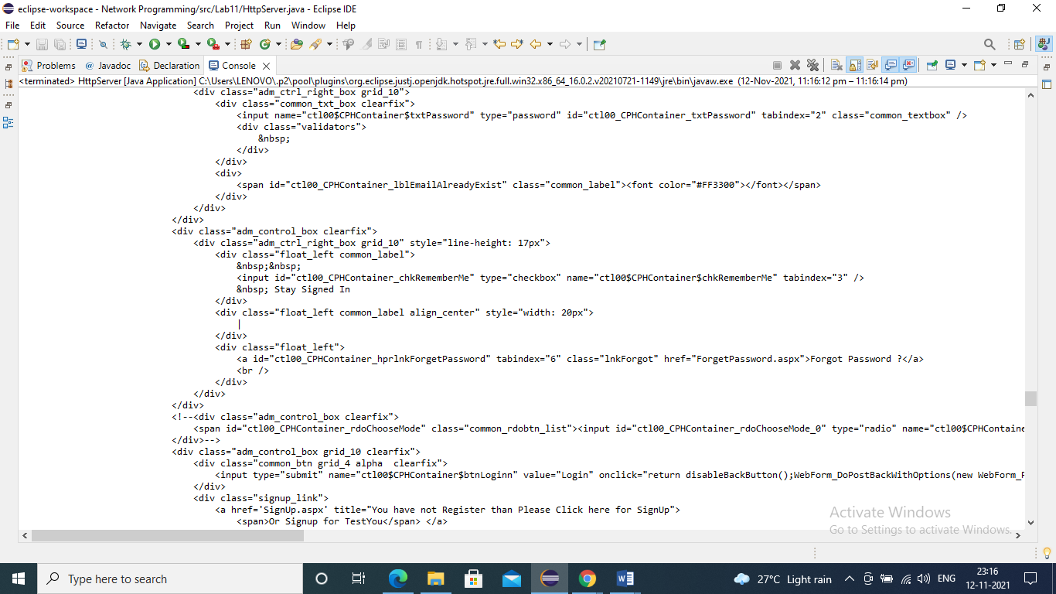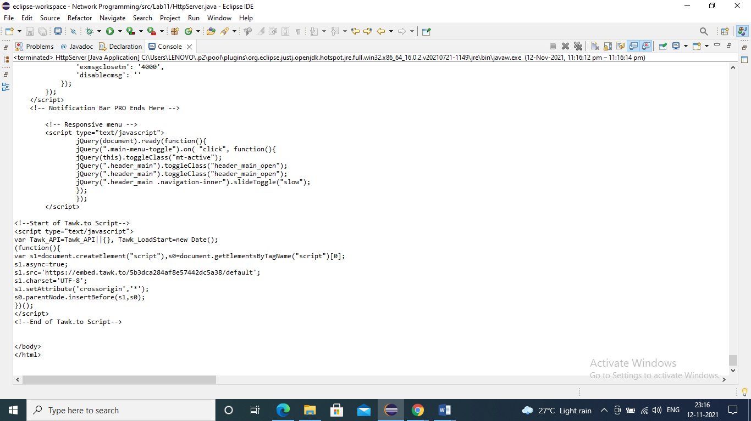

**Writing to Server**

**HttpWrite.java**

**package** Lab11;

**import** java.io.IOException;

**import** java.io.OutputStream;

**import** java.net.InetSocketAddress;

**import** java.util.*;

**import** com.sun.net.httpserver.HttpExchange;

**import** com.sun.net.httpserver.HttpHandler;

**import** com.sun.net.httpserver.HttpServer;

**public** **class** HttpWrite {

**static** Scanner *sin*=**new** Scanner(System.***in***);

**public** **static** **void** main(String[] args) **throws** Exception {

HttpServer server = HttpServer.*create*(**new** InetSocketAddress(8098), 0);

server.createContext("/httpwrite", **new** MyHandler());

server.setExecutor(**null**);

server.start();

}

**static** **class** MyHandler **implements** HttpHandler {

**public** **void** handle(HttpExchange t) **throws** IOException {

System.***out***.println("Enter data to send to server!");

String response = *sin*.nextLine();

t.sendResponseHeaders(200, response.length());

OutputStream os = t.getResponseBody();

os.write(response.getBytes());

os.close();

}

}

}

**Output**

